How does the web work

* Web servers and web browsers communicate via HTTP
* HTTP ensures that all parts of the web page are delivered
* Web browser decides how these items are displayed

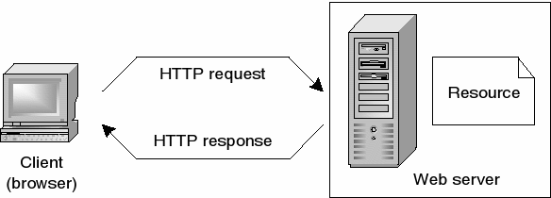

* To be a web developer , you need to have skills in :
* HTML / CSS
* Responsive design skills
* Javascript skills
* Testing and debugging skills
* Interpersonal skills
* Back end basics
* Why I choose to be a web developer:
* Competitive Salaries. ...
* Job Security. ...
* Low Barrier to Entry. ...
* Various Niches to Choose From. ...
* Potential to Work from Home. ...
* The Opportunity to Freelance. ...
* A Strong Community.